MOTHER TERASA WOMENS’ UNIVERSITY, KODAIKANAL

SRI ADI CHUNCHANAGIRI WOMEN’S COLLEGE, CUMBUM

DATA ANALYTICS WITH TABLEAU

Activity: A Global CO2 Emission Analysis Unearthing the Environmental Impact of Human

**Name** : ISWARYA.M

**Email**: iswaryamaharaja583@gmail.com

**NM_ID**: A39E906E38656D4B0794FAE241BE5D17

**Team Leader**: ISWARYA.M

**Team Members**: A.KAVIYA

I.KAVIYA

S.KAVIYA

S.MANIBHARATHI

**1.INTRODUCTION**:

**1.1OVERVIEW OF PROJECT:**

**Global warming is one of the biggest challenges currently being faced by the human race, although correlation is not causation, a likely cause of global warming is due to increased atmospheric carbon dioxide from human activities. CO2 Emission refers to the Carbon Dioxide**

**1.2 PURPOSE:**

**Analysing Global Co2 Emission across countries from 1975 to 2020. This dataset contains a record of Co2 Emission by each Country and Region of Earth, here we are going to analyse and visualise Country wise, Region wise and Overall Co2 Emission on Earth.**

**2.PROBLEM DEFINITION & DESIGN THINKING :**

**2.1 EMPATHY MAP :**

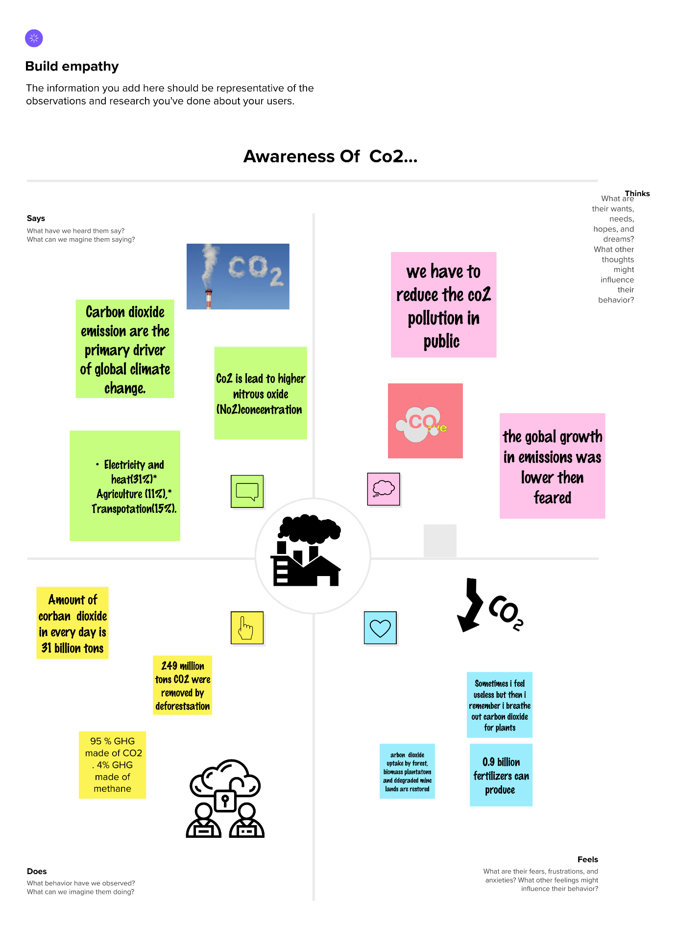

**2.2 IDEATION & BRAIN STROAMING :**

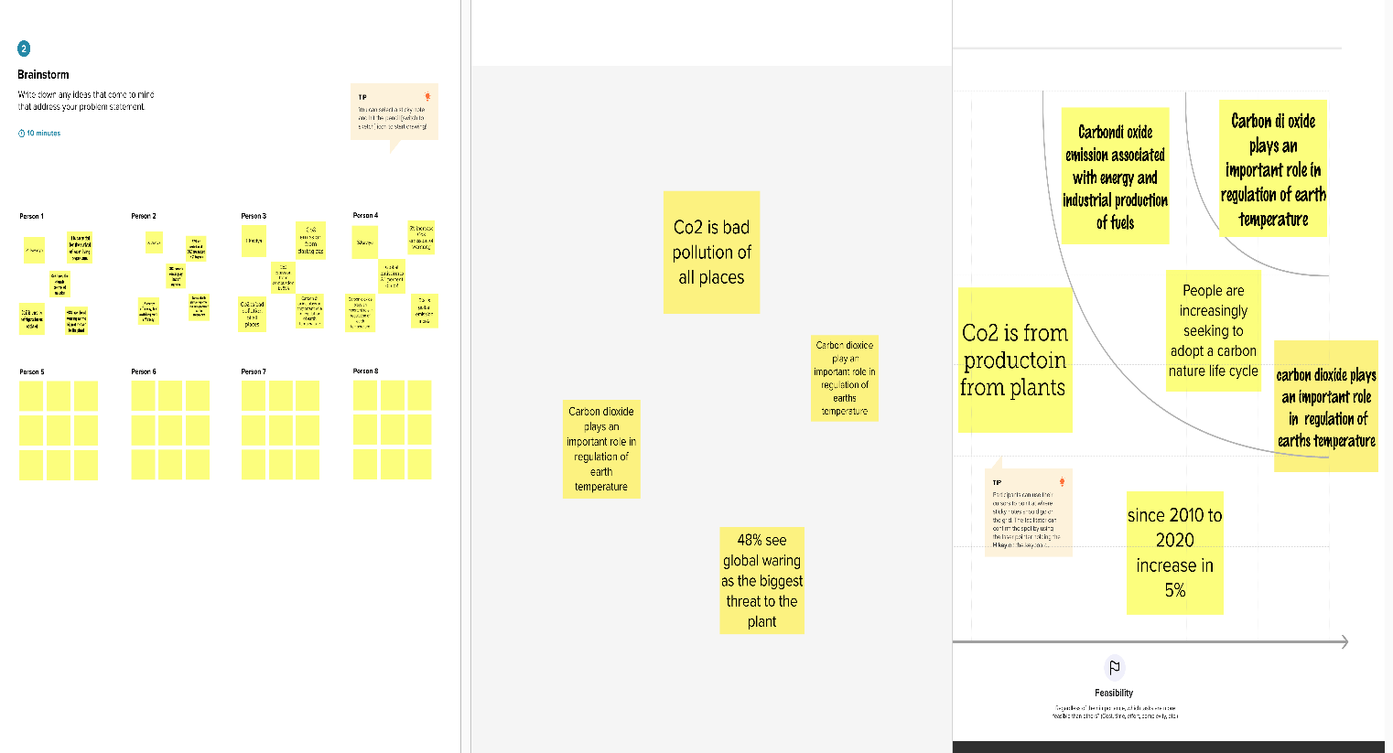

**3.RESULT FINDING (OUTPUT) OF THE PROJECT :**

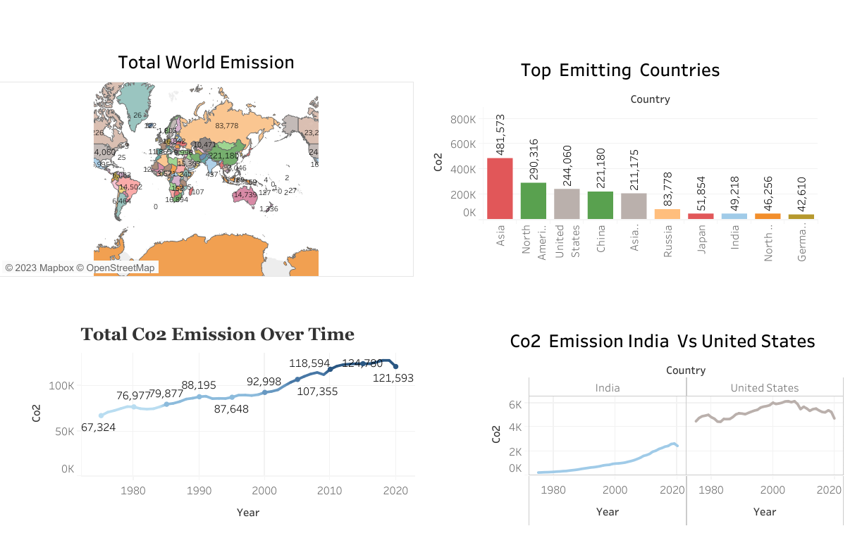

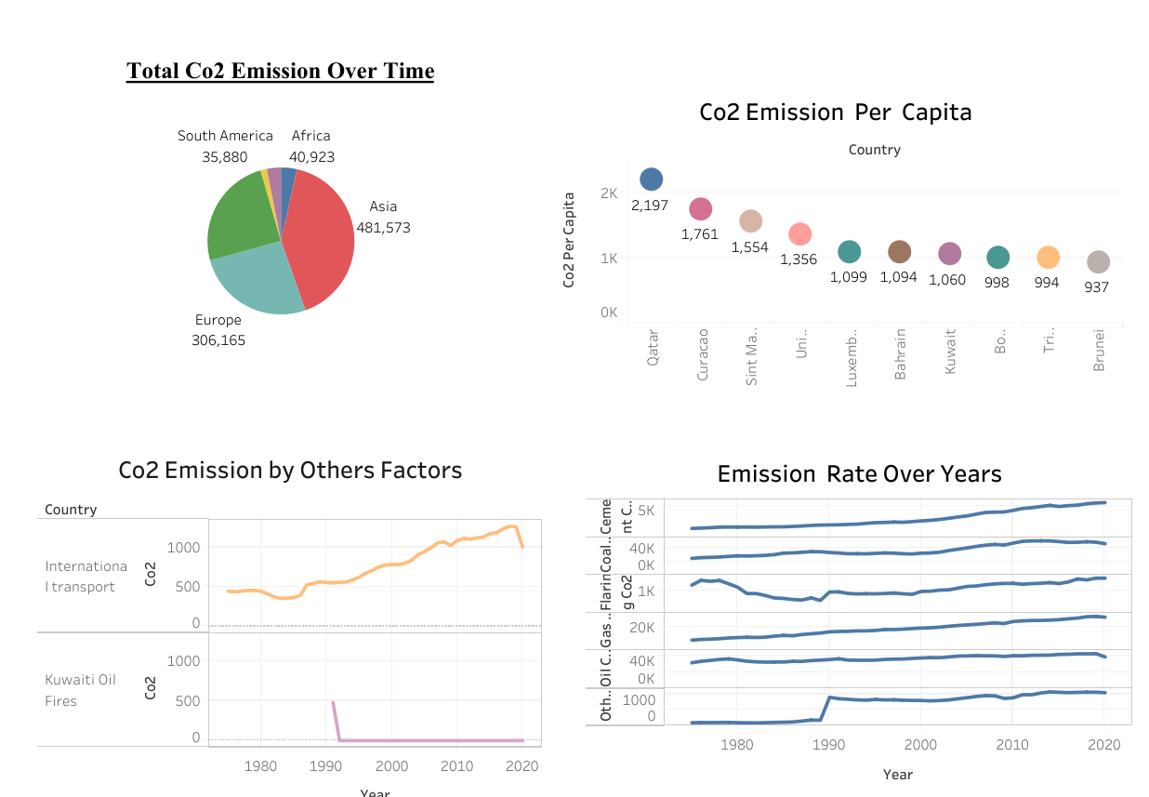

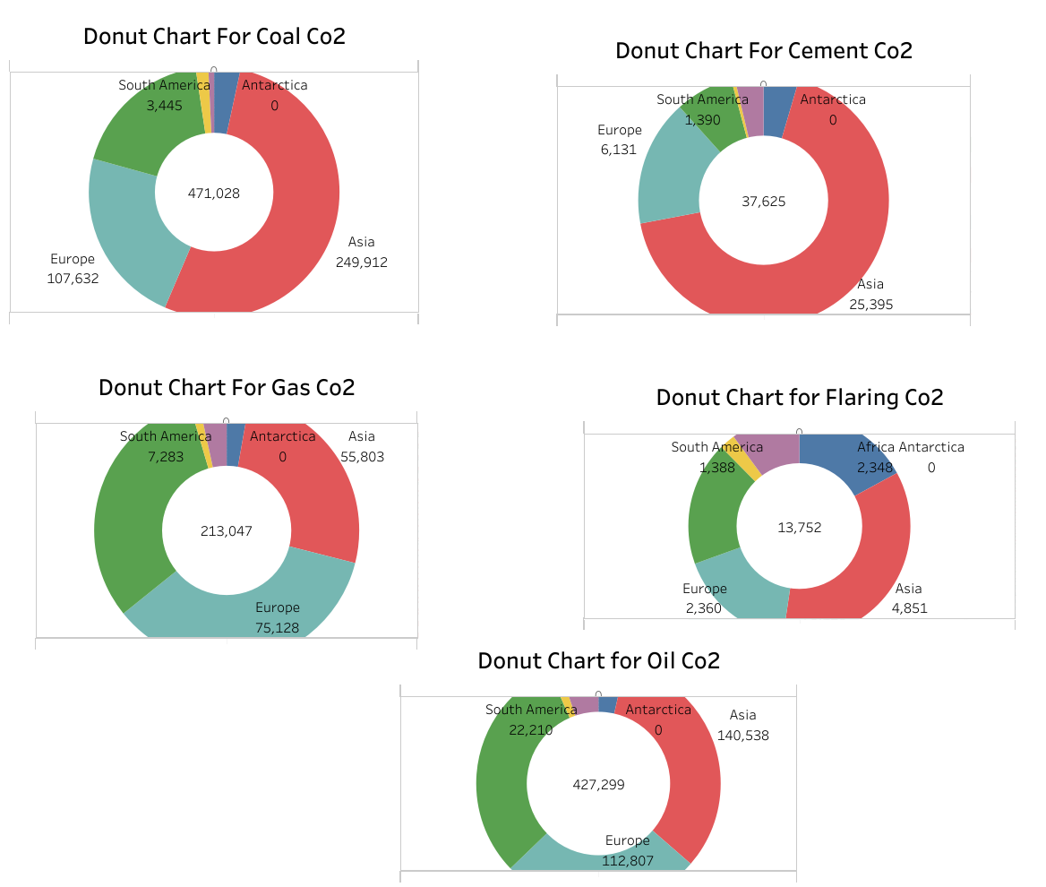

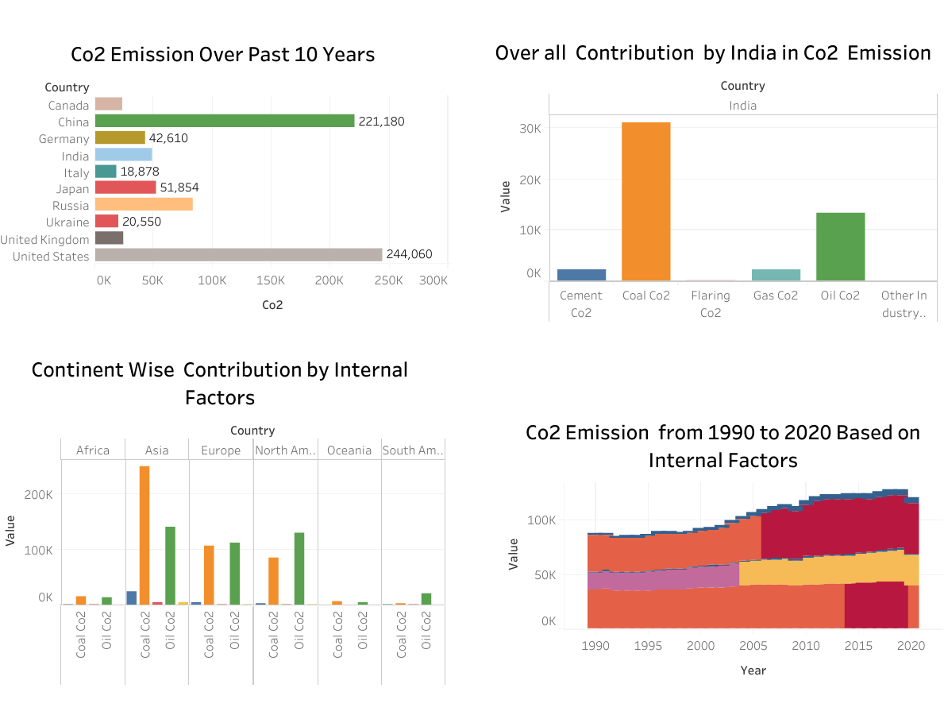

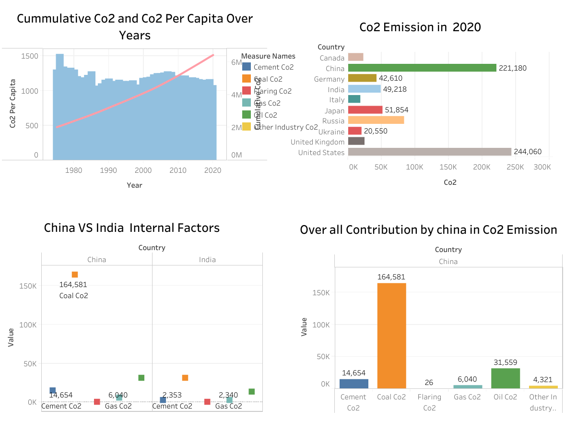

**STORY:**

**STORY 1:**

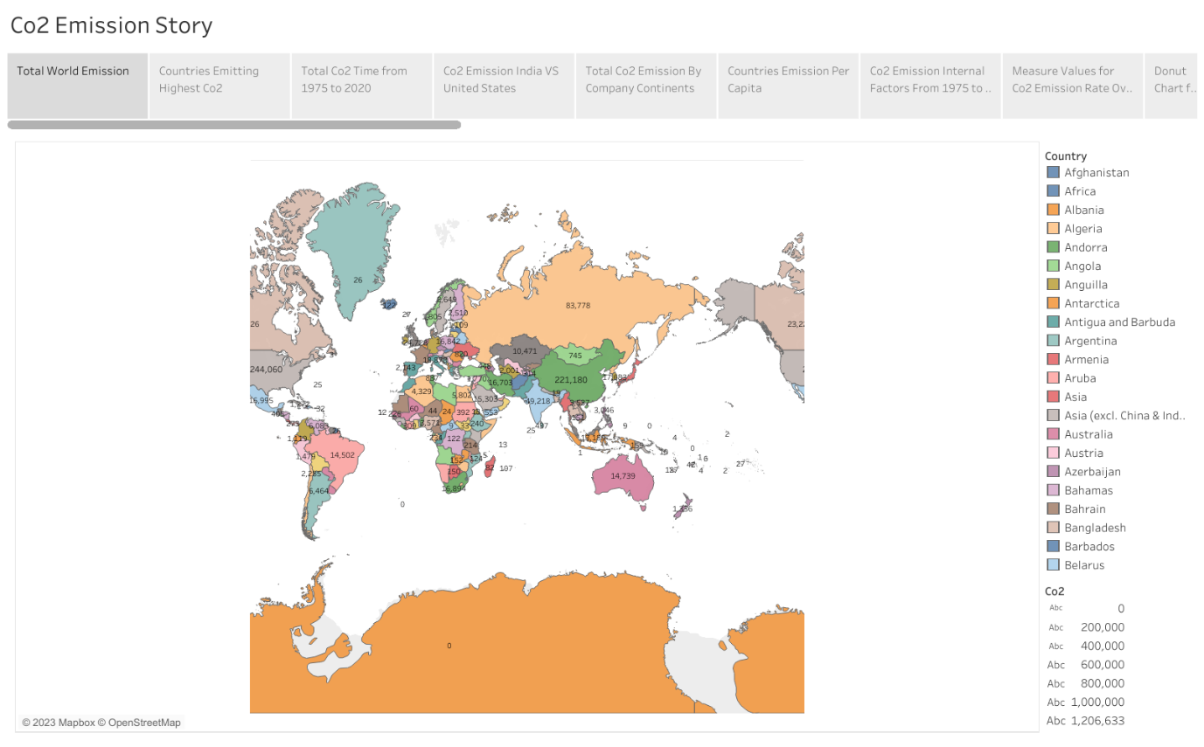

**STORY 2:**

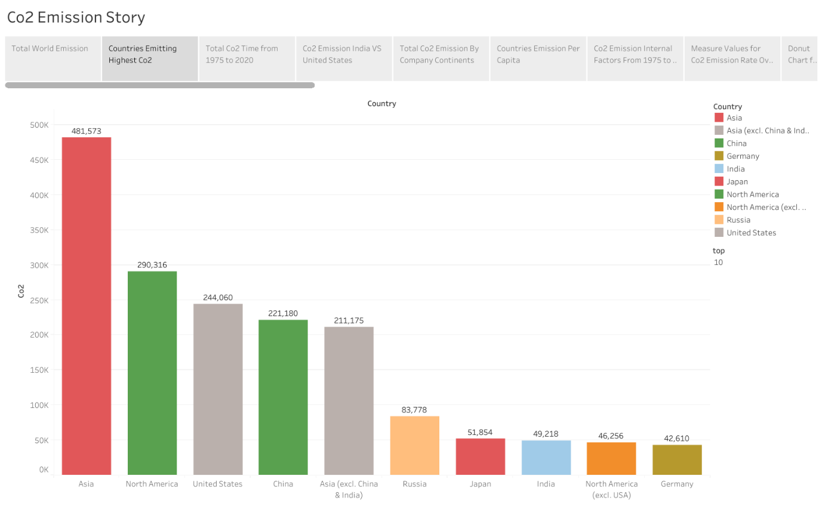

**STORY 3:**

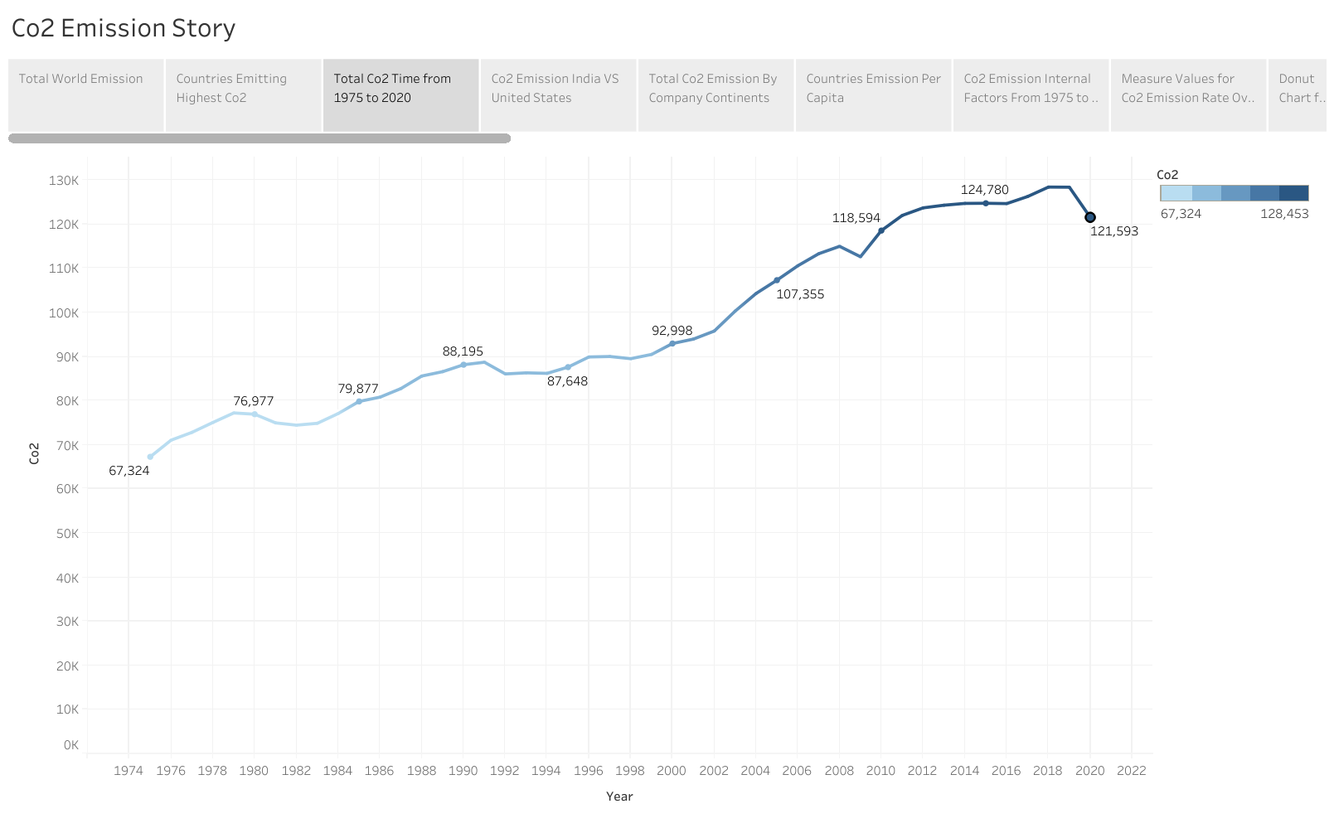

**STORY 4:**

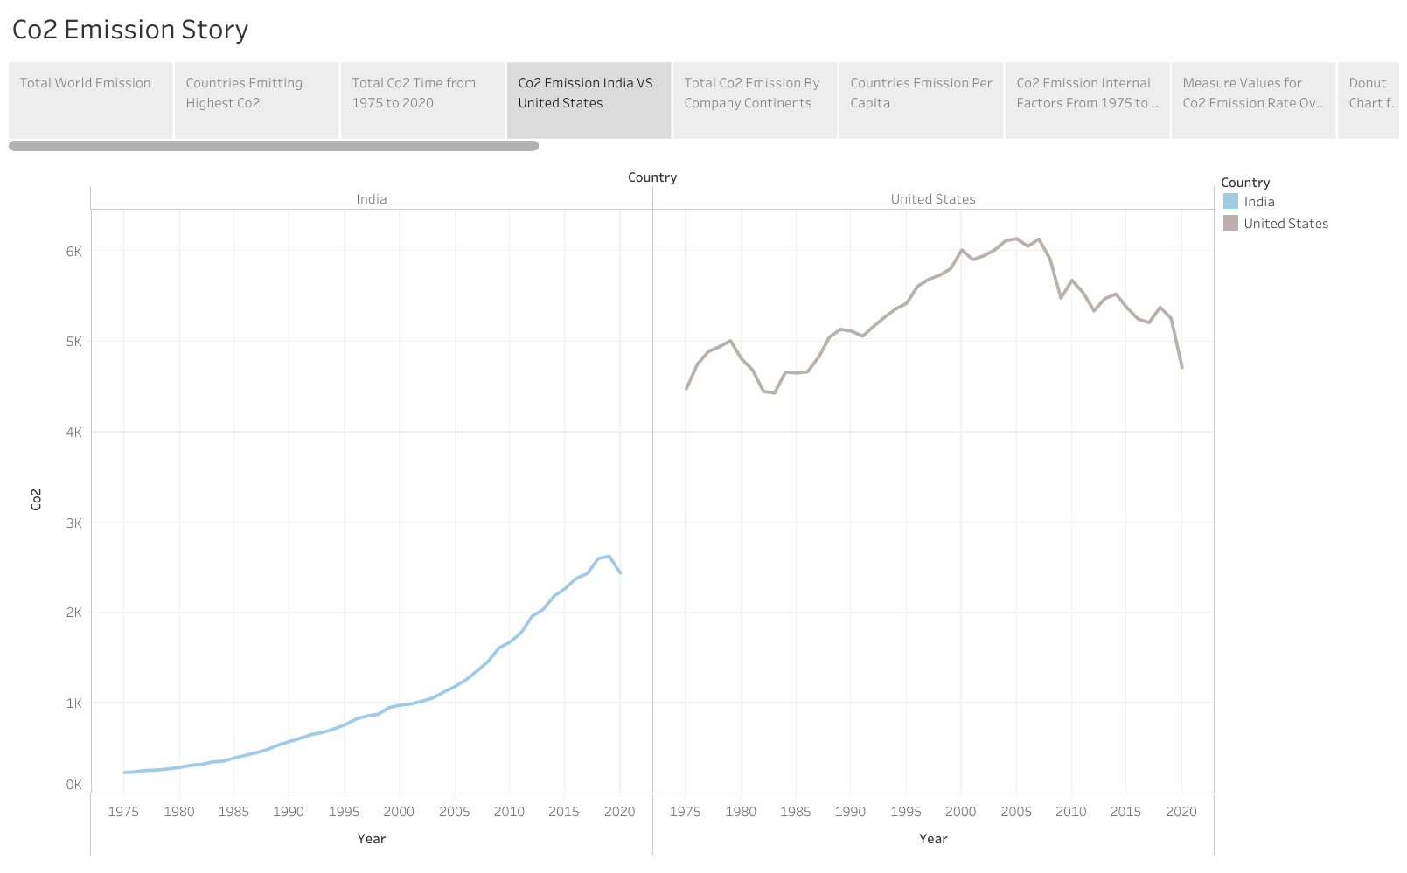

**STORY 5:**

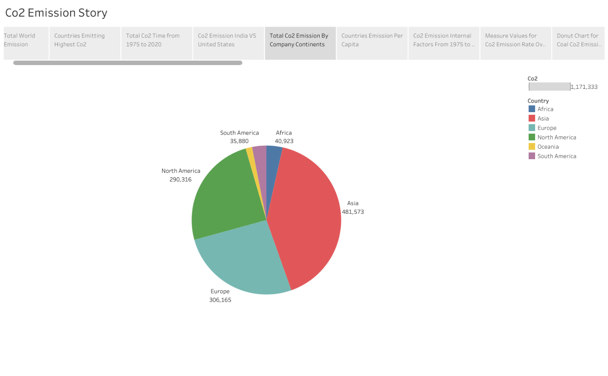

**STORY 6:**

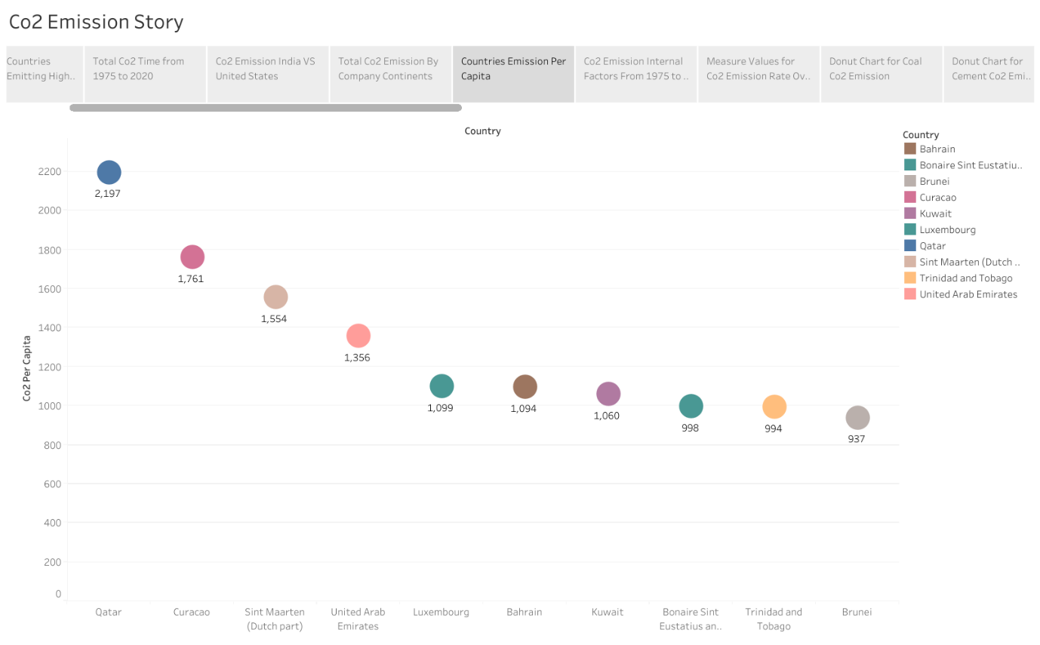

**STORY 7:**

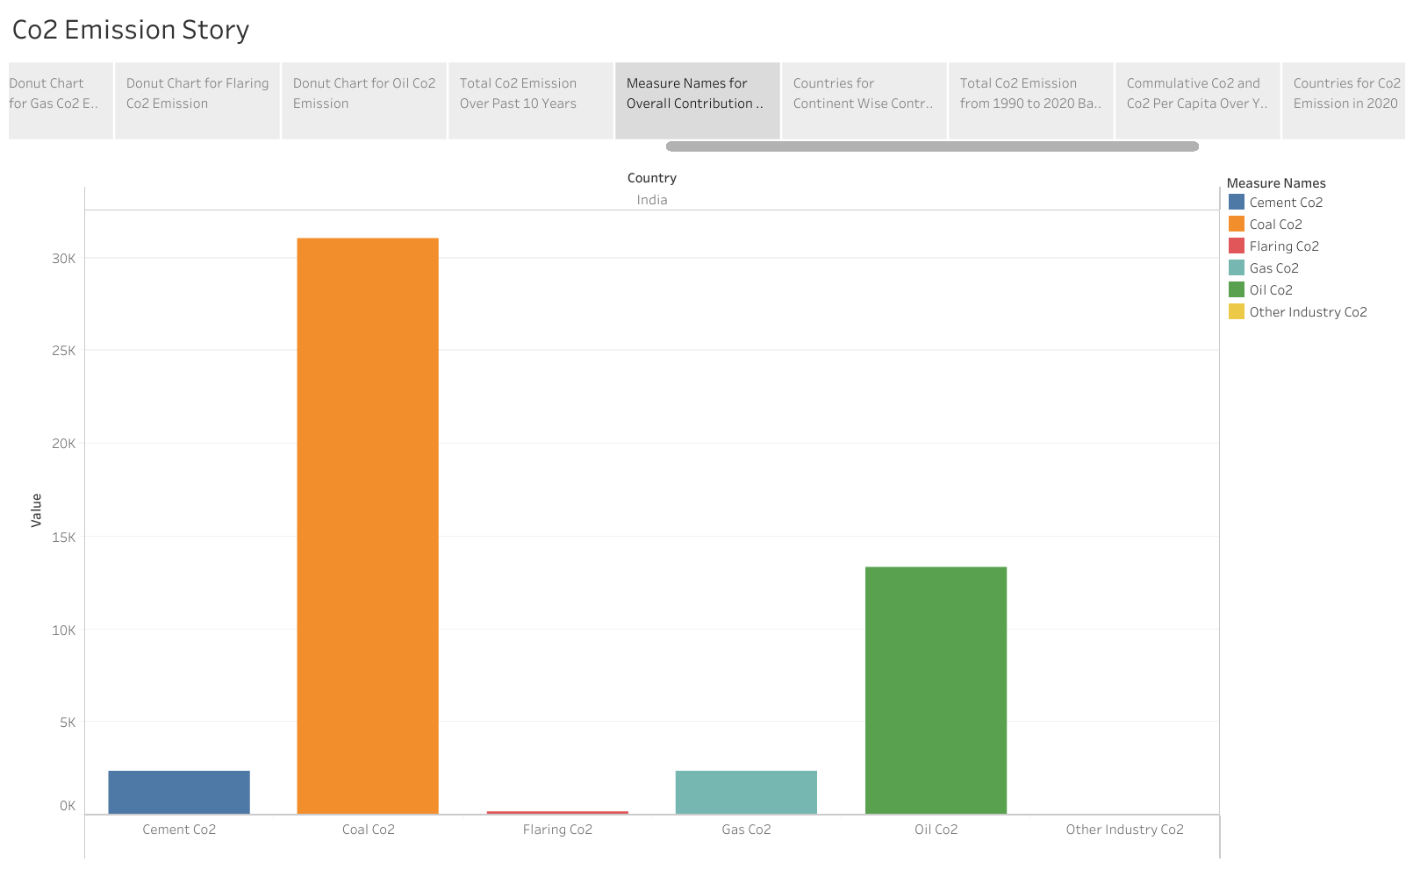

**STORY 8:**

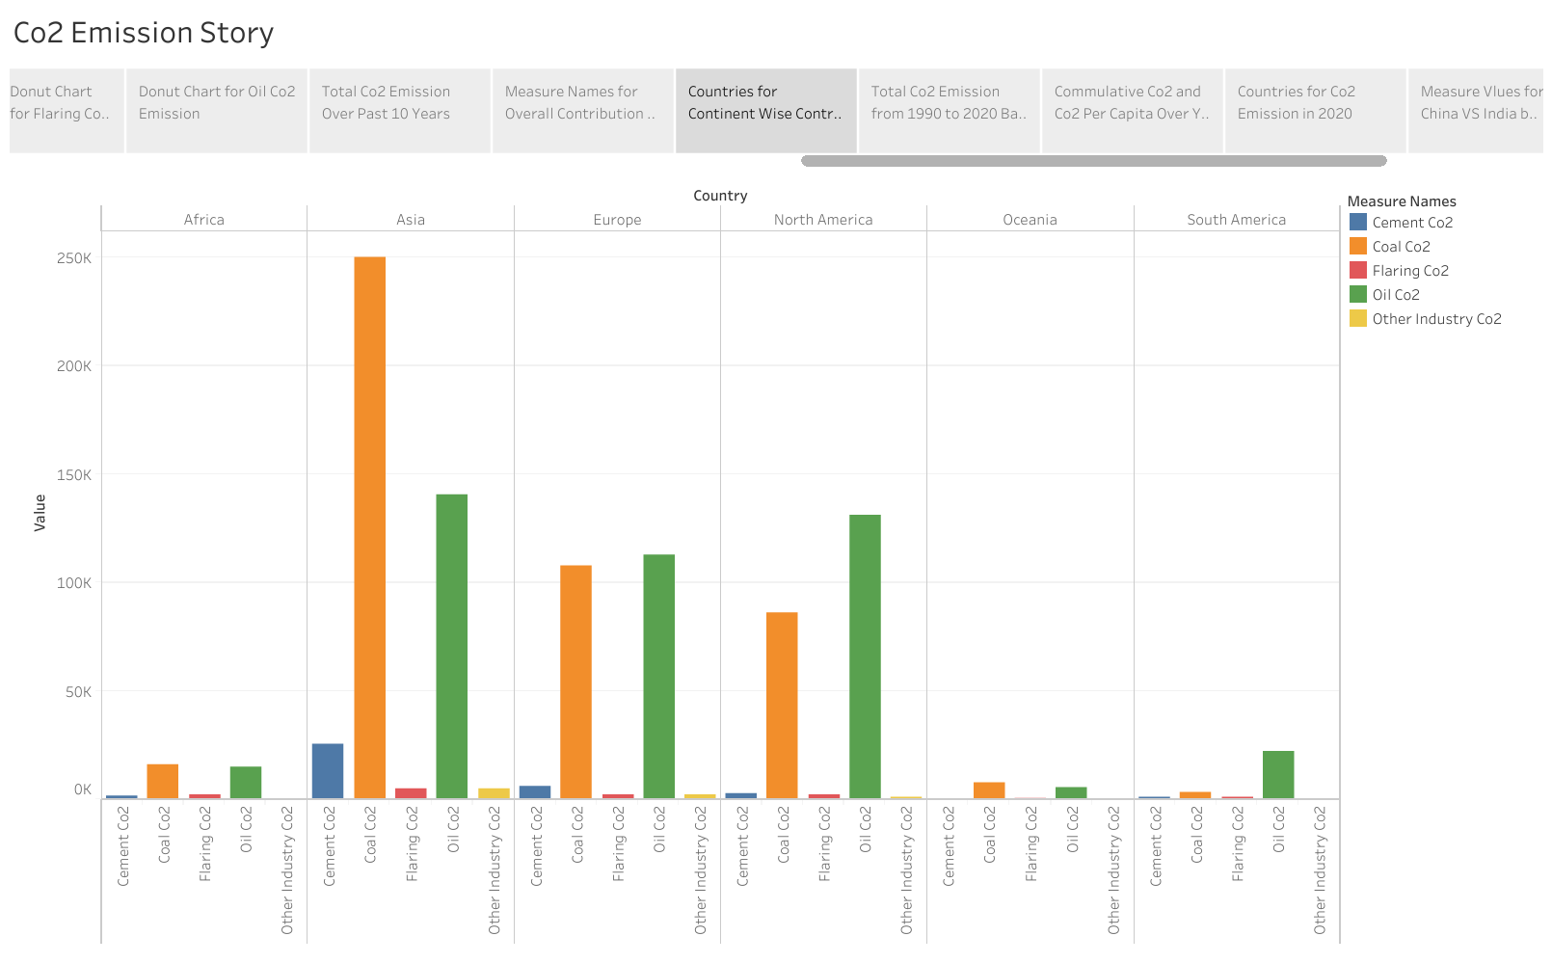

**STORY 9:**

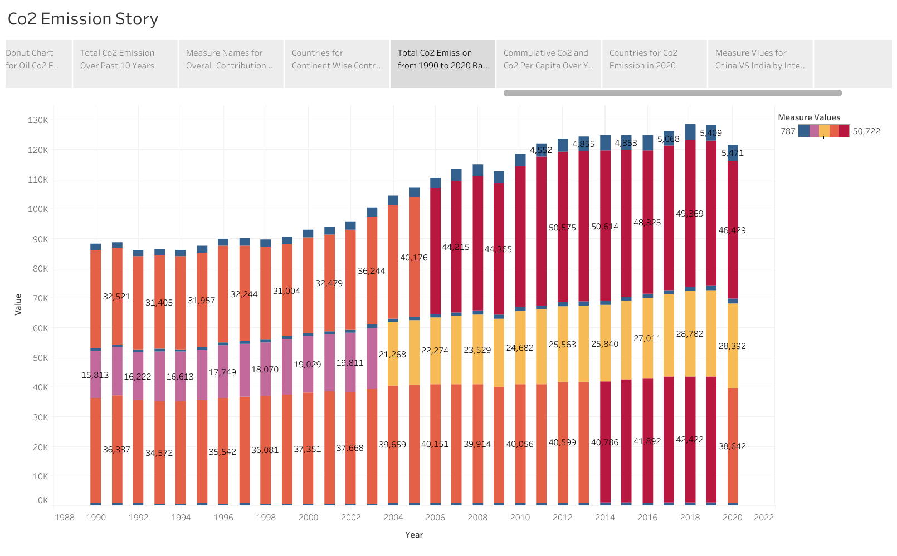

**4.ADVANTAGE & DISADVANTAGE :**

**ADVANTAGE:**

**Carbon is in carbon dioxide, which is a greenhouse gas that traps heat close to Earth. It helps Earth hold some of the heat it receives from the Sun so it doesn't all escape back into space. But CO2 is only good up to a point – beyond that point, Earth's temperature warms up too much. NASA research satellites such as OCO-2 and OCO-3 are studying how carbon moves around the planet.**

**DISADVANTAGE :**

**Carbon dioxide gas can be toxic and very harmful to humans, It increases**

**the temperature of the Earth’s atmosphere, It causes the global warming effect that has bad effects on the Earth.**

**5.APPLICATION :**

**Carbon dioxide gas is used to make urea (used as a fertilizer and in automobile systems and medicine), methanol, inorganic and organic carbonates, polyurethanes and sodium salicylate. Carbon dioxide is combined with epoxides to create plastics and polymers**

**Carbon dioxide gas is used in enhanced oil recovery (EOR). EOR is a class of techniques for increasing the quantity of extracted crude oil from oil fields. Carbon dioxide is injected under high pressure into an oil reservoir, which pushes the oil through pipes and up to the surface of the ground. Carbon dioxide gas injection aids oil recovery and reduces the viscosity of recovered oil.**

**6.CONCLUSION :**

**All living things on Earth contain carbon. Even you contain carbon. Lots of it! Like every other living thing on this planet, we are a part of Earth's carbon cycle. Plants take in CO2. They keep the carbon and give away the oxygen. Animals breathe in the oxygen and breathe out carbon dioxide. Carbon, including carbon dioxide, has cycled into and out of the air for a long time. This cycling of carbon has stayed balanced over long periods of time**

**7. FUTURE SCOPES :**

**No climate policies: projected future emissions if no climate policies were implemented; this would result in an estimated 4.1 to 4.8°C warming by 2100 (relative to pre-industr** **In the visualization we see the various emissions scenarios to achieve 2°C depending on the year that global emissions peak ial temperatures)**